PROCEDURES
Setup: Employees Table
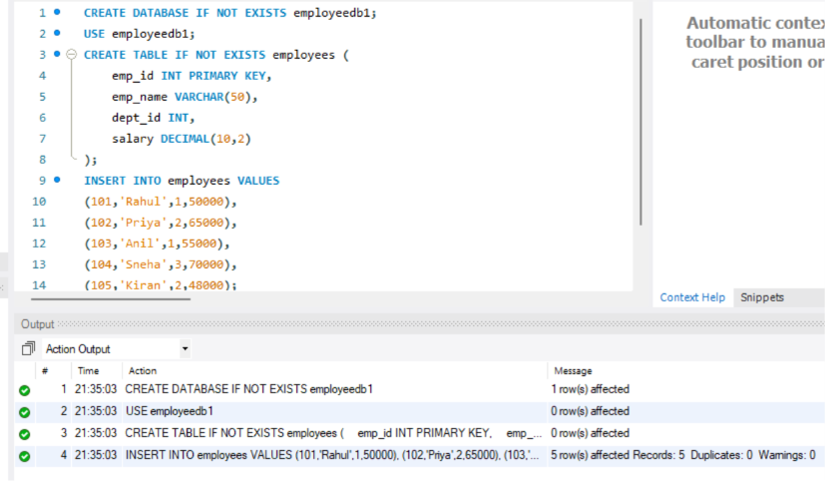
- Verify Data
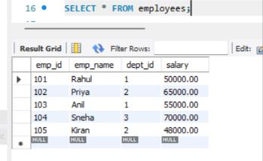
Procedure 1 – Display All Employees
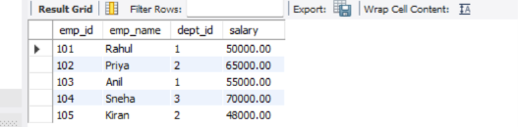
Procedure 2 – IN Parameter
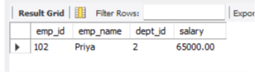
Procedure 3 – Update Salary
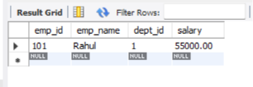
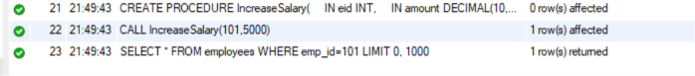
Procedure 4 – Aggregate Function
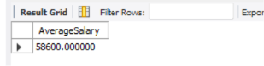
Procedure 5 – JOIN
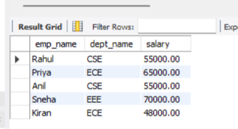
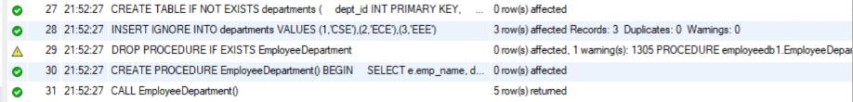
Procedure 6 – GROUP BY and AVG
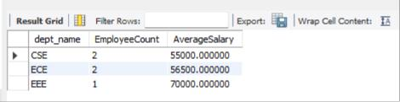
Procedure 7 – IF or ELSE
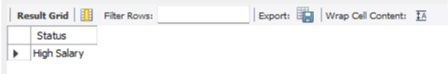
Procedure 8 – OUT Parameter
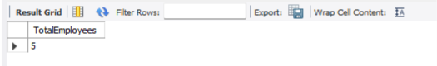
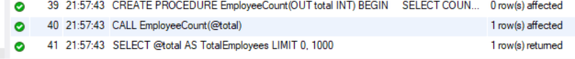
Procedure 9 – INOUT Parameter
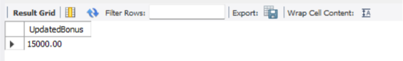
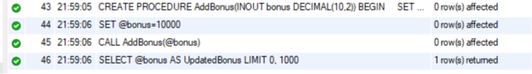
Procedure 10 – Transaction
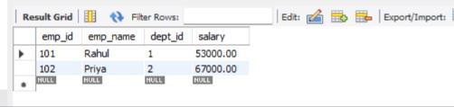
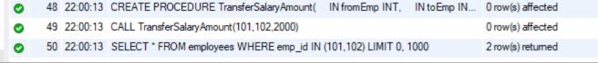

JOINS AND TRANSACTIONS
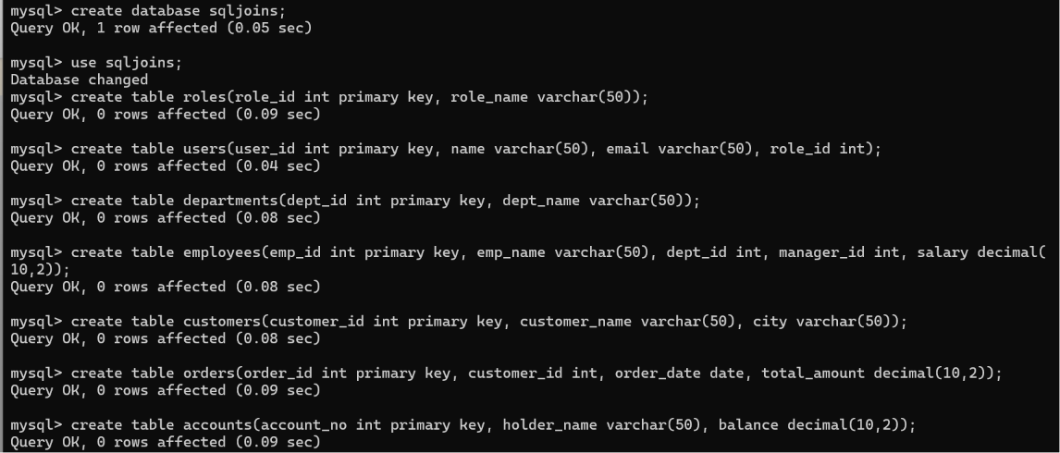
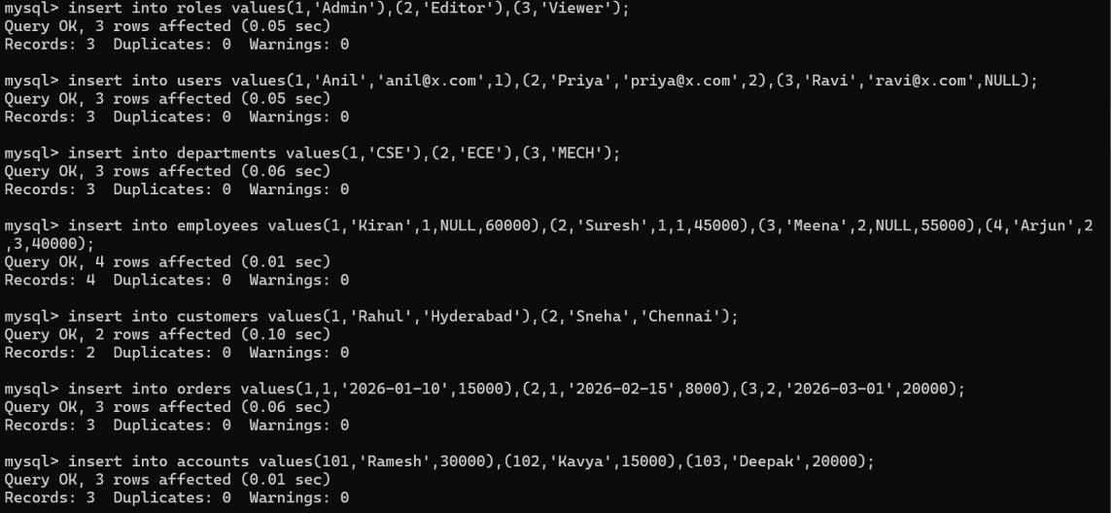
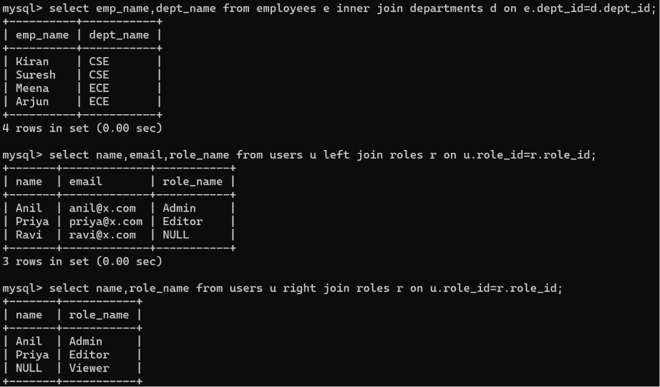
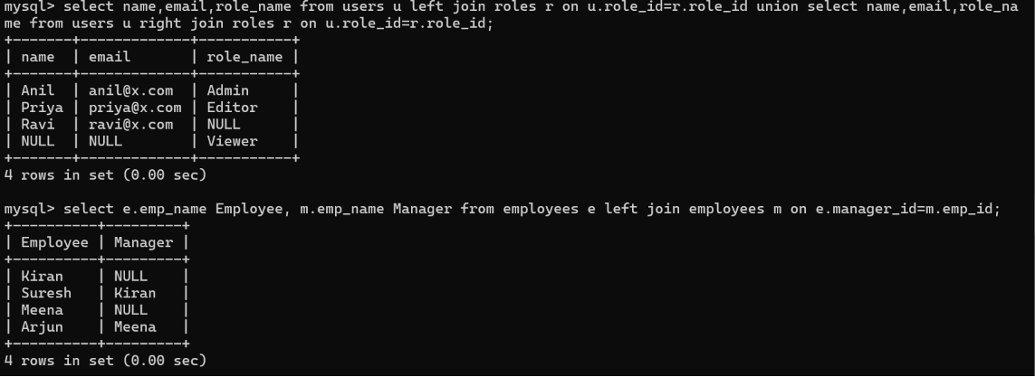
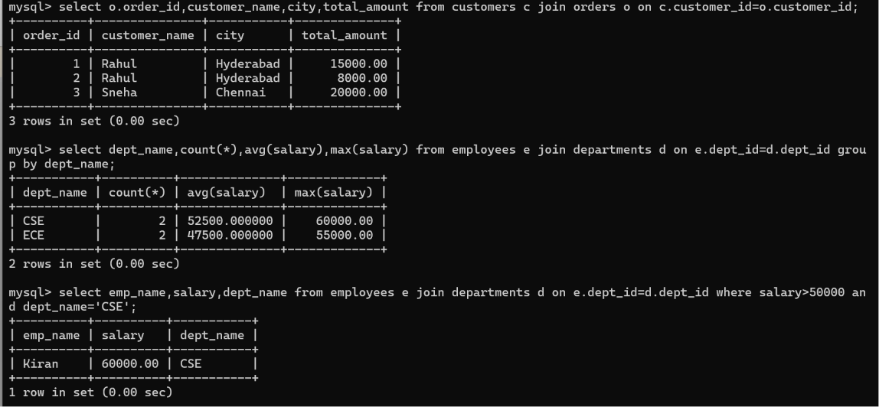
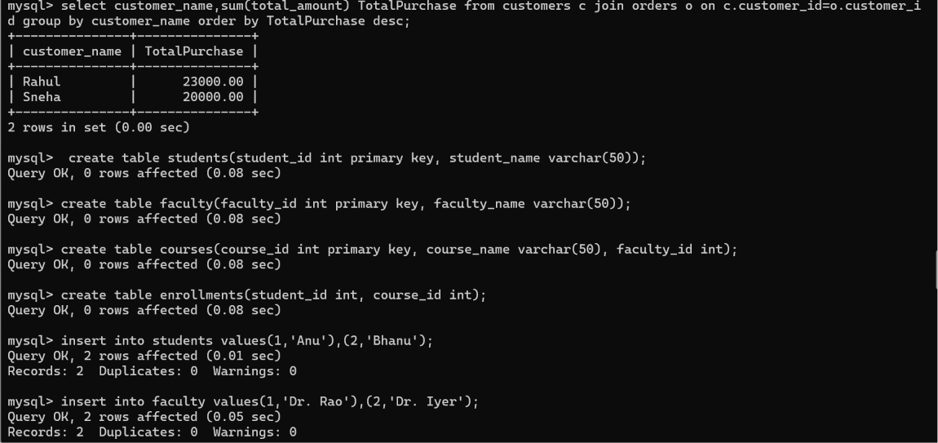
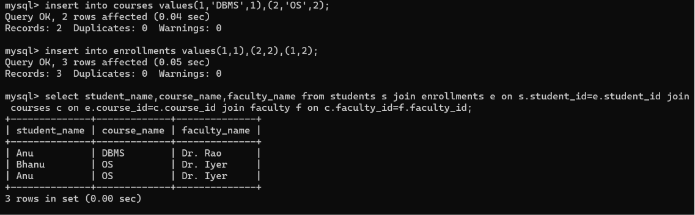
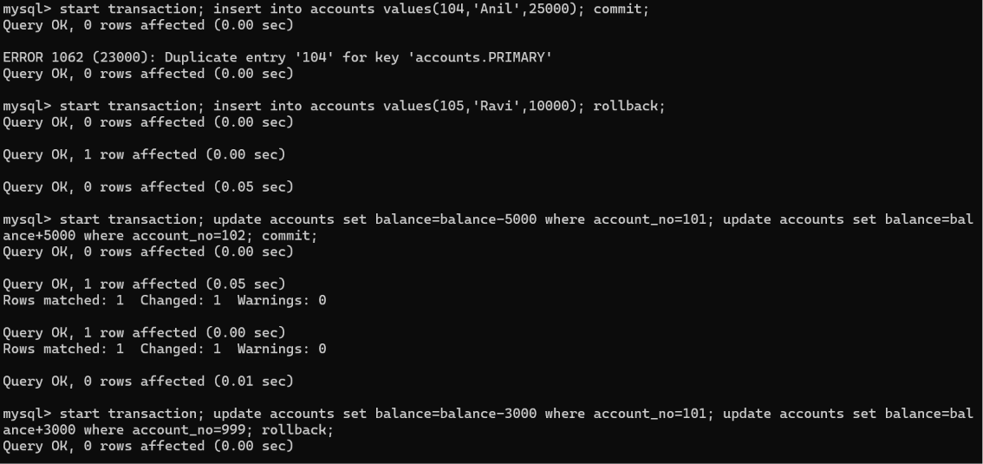
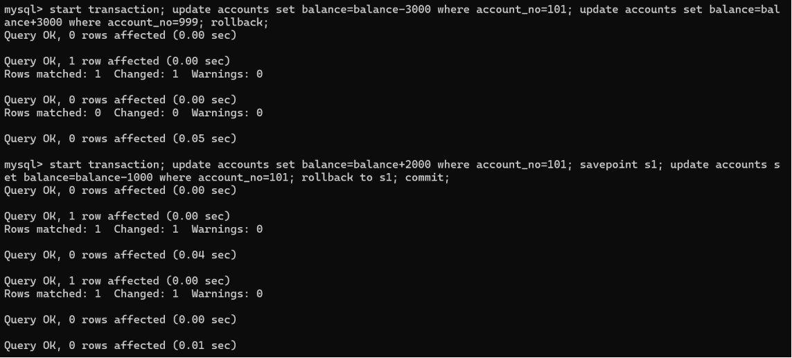
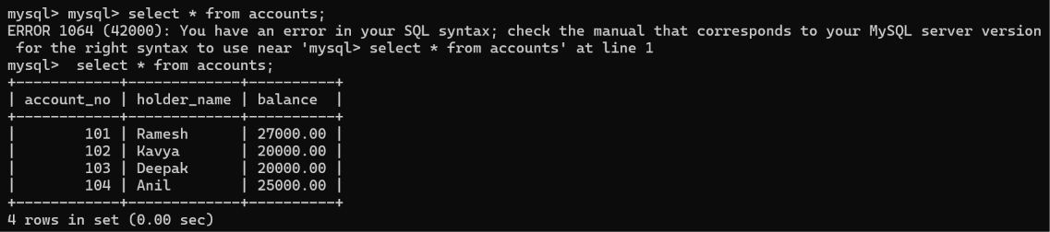

MYSQL VIEWS
Setup: Employees and Departments Tables
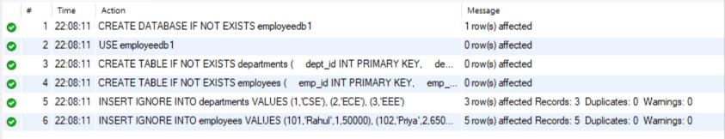
Verify the Tables
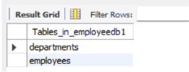
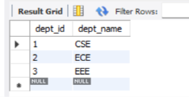
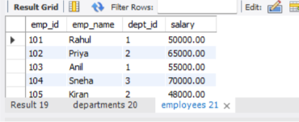
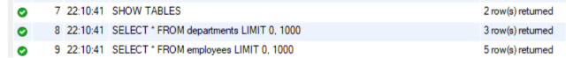
View 1 – Display All Employees
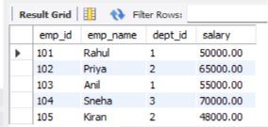
View 2 – Selected Columns
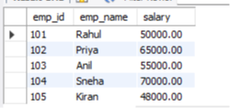
View 3 – High Salary Employees
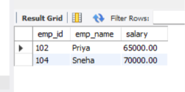
View 4 – Employee and Department using JOIN
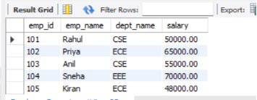
View 5 – Employees from a Particular Department
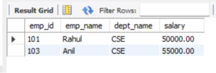
View 6 – Department-wise Average Salary
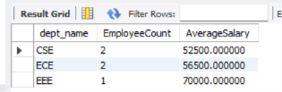
View 7 – Departments with Average Salary Above 55000
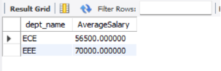
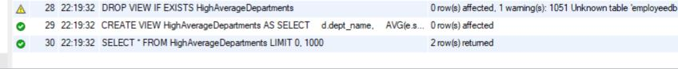
View 8 – Salary Range View
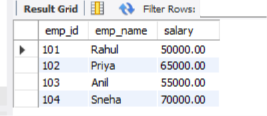
View 9 – View with Calculated Column
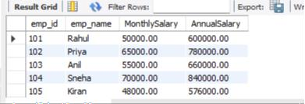
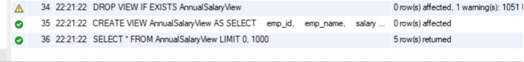
View 10 – Update Data Through a Simple View
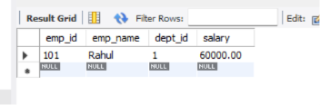
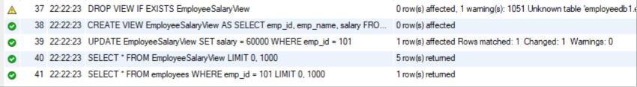
View 11 – REPLACE OR CREATE THE VIEW
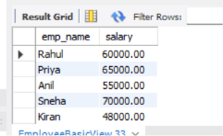
View 12 – View Definition
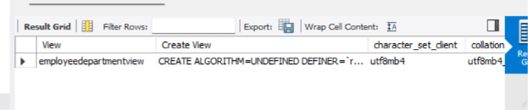
View 13 – List All Views
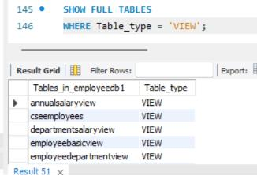
View 14 – Drop a View

TRIGGERS
Create database:
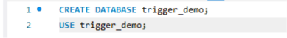
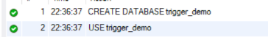
Step 1: Create the main table
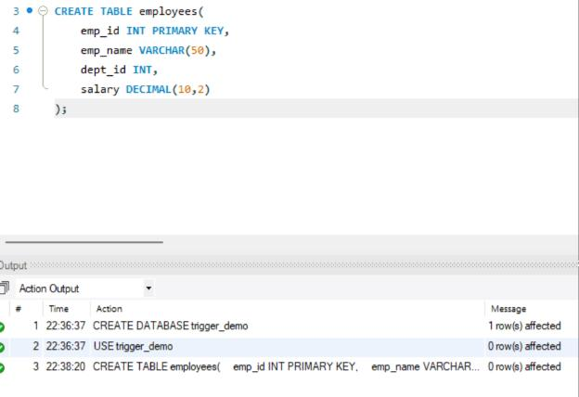
Step 2: Create the audit table
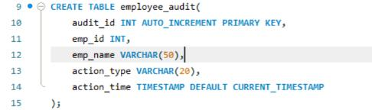
Step 3: Trigger 1 — AFTER INSERT
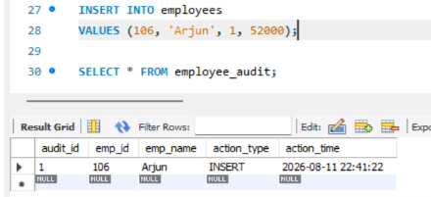
Step 4: Trigger 2 — AFTER DELETE
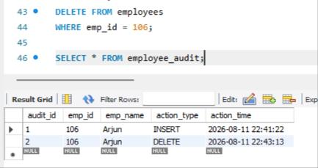
Step 5: Trigger 3 — AFTER UPDATE
Step 6: Trigger 4 — BEFORE INSERT
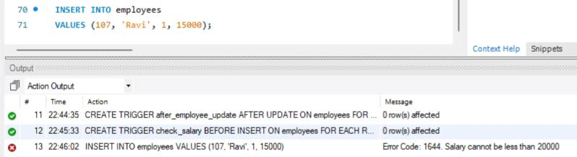
INSERT INTO employees VALUES (108, 'Meena', 1, 30000);
Step 7: Trigger 5 — BEFORE UPDATE
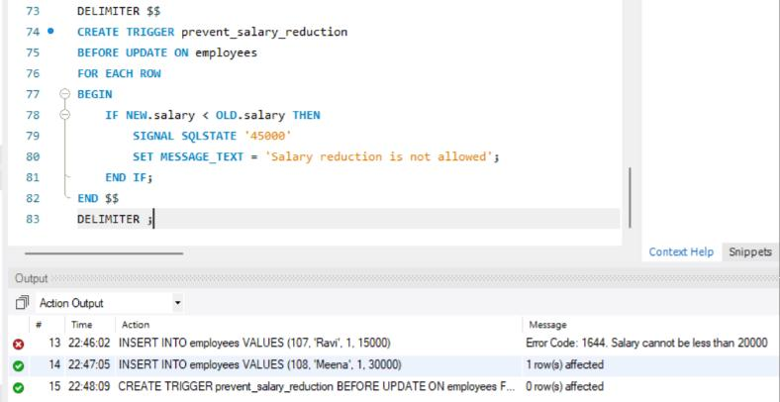
Step 8: Add employee 101 for test updates
